# Assignment 3

## 1/4.

The network was visualized, see appendix A.

## 2/4.



## 3/4.

PCA was applied and scatter plot was constructed, see figure 1.

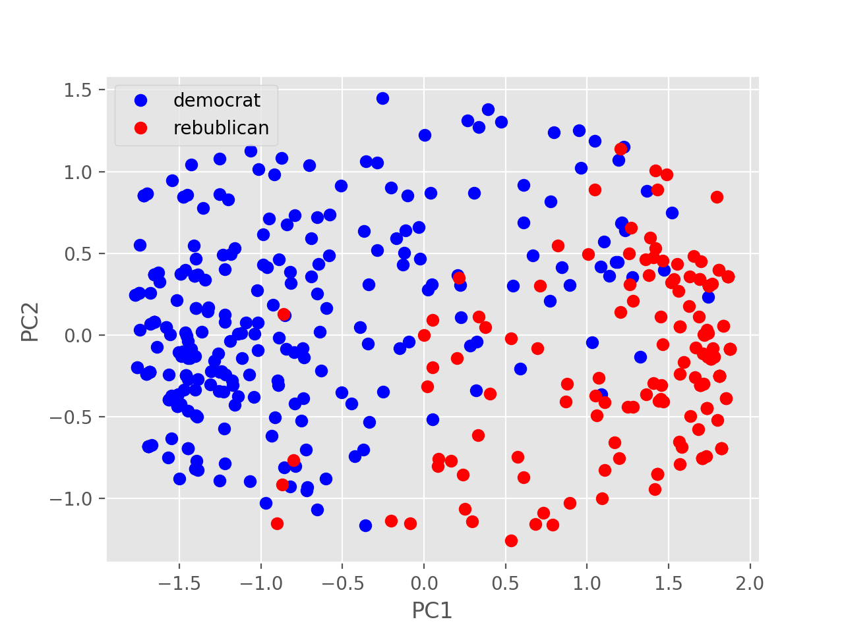

*Figure 1. Visualization of the US congress voting after dimension reduction into 2D applying PCA.*

## 4/4.

Metric MDS and Sammon mapping were computed and plotted, see figure 2. Shepard plots were computed for these methods, see figure. It’s hard to define which one predicts better. Predictions seem to equal.

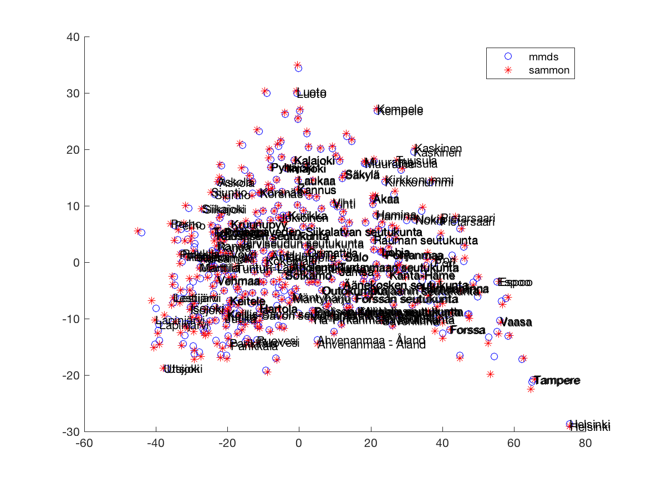

*Figure 2. Visualization of the statistics of Finnish municipalities* *after applying MMDS and Sammon mapping.*

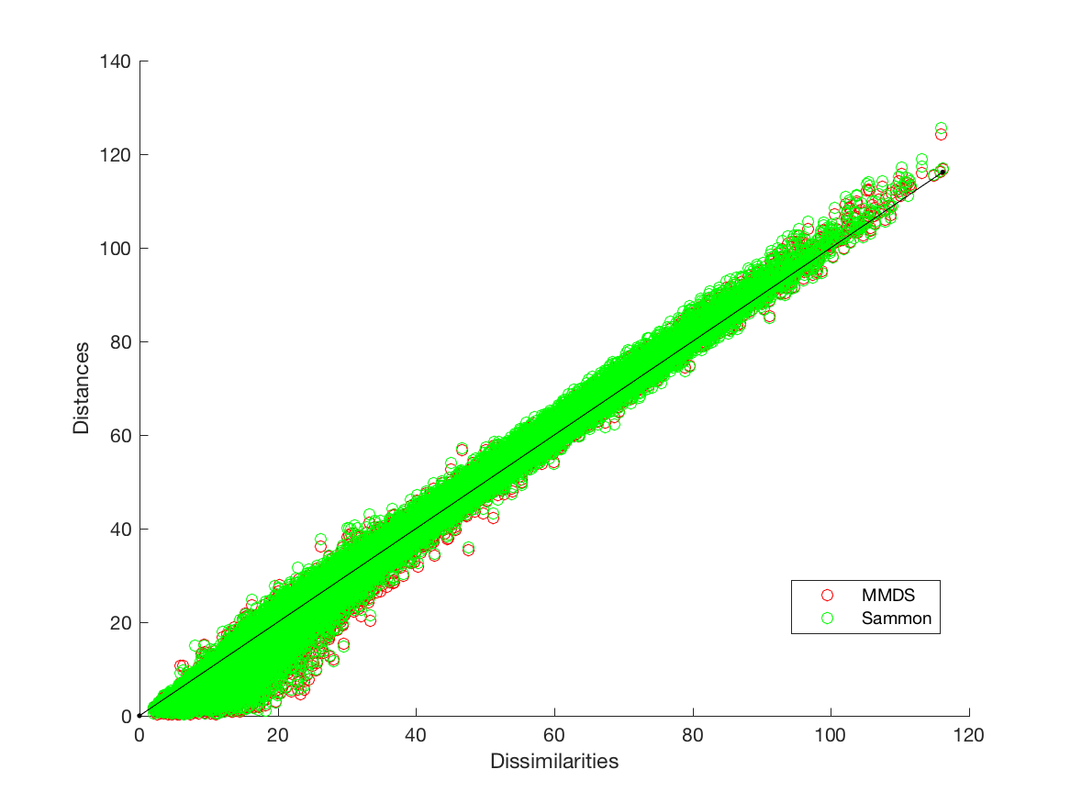

*Figure 3. Shepard plot the statistics of Finnish municipalities* *after applying MMDS and Sammon mapping.*